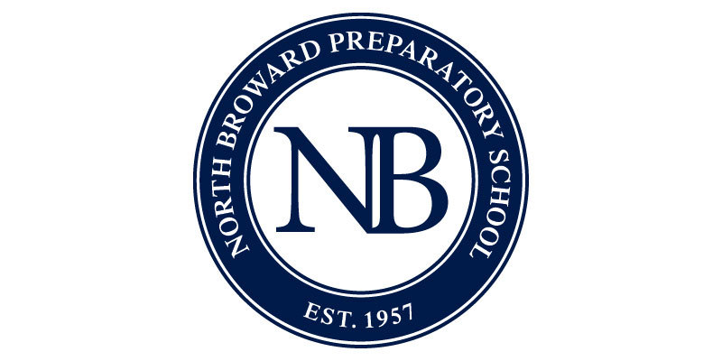

NBPS Club Charter Form

I. Club Charter

- Club Name:

- Faculty Sponsor:

- Type of Club (bold or highlight one): 1. Service 2. Fundraising 3.Other
4. Honor Societies 5. Culture/Language
6.Learning/Education

- Mission Statement:

- Membership qualifications:

- Relation to the Curriculum:

- Faculty Sponsor’s Role:

- Meeting Time:

- Description for Website:

- Questions:

  - Why do you need club status(Be specific)?

  - What NB club are you most similar to?

  - What qualities does your potential club possess that separate it from the club mentioned above?

  - What is your potential member base? Be as specific as possible.

  - What ideas do you have for a club sponsored event?

- Additional Information (optional):

